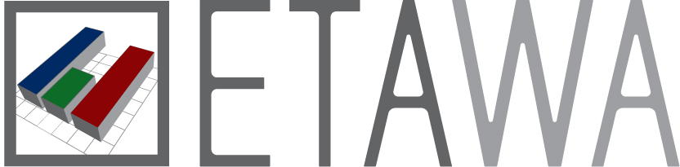**Economic Teachers Association of W.A.**

**Examination, 2014**

**Question/Answer Booklet**

ECONOMICS

**Stage 3**

**Student No: __________________________________________**

#### Time allowed for this paper

Reading time before commencing work: ten minutes

Working time for paper: three (3) hours

**Materials required/recommended for this paper**

***To be provided by the candidate***

Standard items: pens (blue/black preferred), pencils (including coloured), sharpener,

correction fluid/tape, eraser, ruler, highlighters

Special items: non-programmable calculators approved for use in the WACE examinations

**Important note to candidates**

No other items may be taken into the examination room. It is **your** responsibility to ensure

that you do not have any unauthorised notes or other items of a non-personal nature in the

examination room. If you have any unauthorised material with you, hand it to the supervisor **before** reading any further.

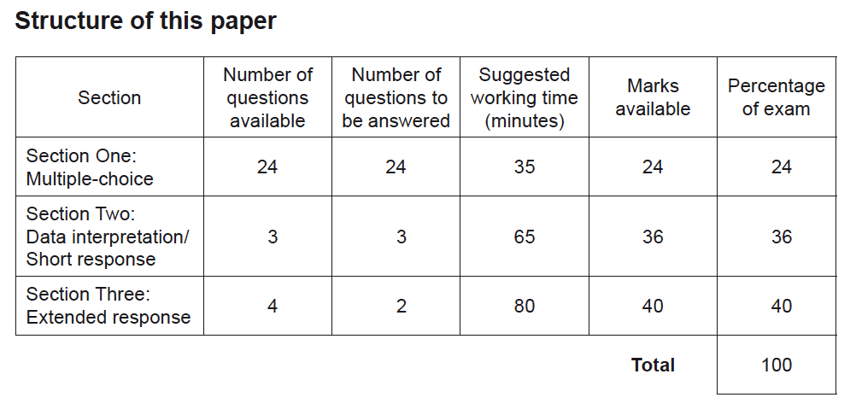

**Instructions to candidates**

1. Answer the questions according to the following instructions.

**Section One**: Answer all questions on the separate Multiple-choice Answer Sheet provided. For each question shade the box to indicate your answer. Use only a blue or black pen to shade the boxes. If you make a mistake, place a cross through that square, then shade your new answer. Do not erase or use correction fluid/tape. Marks will not be deducted for incorrect answers. No marks will be given if more than one answer is completed for any question.

**Section Two**: Write answers in this Question/Answer booklet. Spare pages are included at the end of the booklet. They can be used as additional space if required to continue an answer. If you need to use the space to continue an answer, indicate in the original answer space where the answer is continued, i.e. give the page number. Fill in the number of the question(s) you are continuing at the top of the page.

**Section Three**: Write answers in this Question/Answer booklet. Pages are included at the end of this booklet for planning and writing your answer.

* Planning: If you use the spare pages for planning, indicate this clearly at the top of the page.
* Answering the question: In the pages provided indicate clearly the number of the question you are answering.

2. You must be careful to confine your responses to the specific questions asked and to follow any instructions that are specific to a particular question.

**Section 1: Multiple Choice 24% (24 Marks)**

This section has **24** questions. Answer **all** questions on the separate Multiple-choice Answer Sheet provided.

For each question shade the box to indicate your answer. Use only a blue or black pen to shade the boxes. If you make a mistake, place a cross through that square, then shade your new answer. Do not erase or use correction fluid/tape. Marks will not be deducted for incorrect answers. No marks will be given if more than one answer is completed for any question.

Suggested working time: 35 minutes.

_____________________________________________________________________________________________________________________________________________________________________________________________________

Select the best answer.

1. Which of the following is most likely to slow the process of globalisation?

A. Higher labour mobility

B. Lower costs of communication

C. A decrease in the world price of oil

D. An increase in export subsidies by advanced economies

2. Which of the following combinations is most likely to reduce Australia’s export volumes?

A. The Australian dollar depreciates and there is a contraction in the US economy.

B. The Australian dollar appreciates and there is a contraction in the US economy.

C. The Australian dollar depreciates and there is an expansion in the US economy.

D. The Australian dollar appreciates and there is an expansion in the US economy.

3. Fluctuating exchange rates can alter a multinational firm's profits and losses. German auto maker Volkswagen produces cars in Germany and sells them in Australia. If the Australian dollar depreciates against the euro, then Volkswagen's revenues from these operations should ________ because it will take ________ Australian dollars to purchase the German-made Volkswagens.

A. rise; more

B. rise; fewer

C. fall; more

D. fall; fewer

4. Specialization and trade allow a country to

A. produce and consume on its production possibility frontier.

B. produce and consume inside its production possibility frontier.

C. produce and consume outside its production possibility frontier.

D. produce on its production possibility frontier and consume outside it.

5. Australia’s largest category of imports is

A. services.

B. consumption goods.

C. intermediate goods.

D. capital goods.

6. Suppose Japan produces only two goods, rice and electronics. If Japan has a comparative advantage in electronics, a move toward free trade will:

A. harm electronics workers, benefit rice workers, but benefit the nation as a whole.

B. benefit electronics workers, harm rice workers, but benefit the nation as a whole.

C. harm electronics workers, harm rice workers, but benefit the nation as a whole.

D. benefit electronics workers, harm rice workers, but harm the nation as a whole.

7. A tariff imposed on foreign cars imported into Australia

A. benefits domestic car companies more than the loss of consumer surplus due to the higher price of cars.

B. benefits both domestic car companies and consumers because with greater output firms can sell Australian made cars at a cheaper price.

C. will not affect car imports because people need small foreign cars.

D. benefits domestic car companies less than the loss of consumer surplus due to the higher price of cars.

8. Which of the following would increase Australia’s international competitiveness?

i. A decrease in the exchange rate

ii. A decrease in the financial account surplus

iii. An increase in the capital-labour ratio

iv An increase in the rate of protection

A. i and ii

B. i and iii

C. ii and iii

D. iii and iv

9. Suppose the exchange rate falls from $0.95 US per Australian dollar to $0.90 US per Australian dollar. Australian exports will ________, Australian imports will ________, and Australian aggregate demand will ________.

A. decrease; increase; decrease

B. decrease; increase; increase

C. increase; decrease; increase

D. increase; increase; increase

10. What is the most likely impact of a rise in the level of Australia’s interest rates relative to overseas interest rates?

A. An increase in foreign investment and an appreciation of the $A

B. An increase in foreign investment and a depreciation of the $A

C. A decrease in foreign investment and a depreciation of the $A

D. A decrease in foreign investment and an appreciation of the $A

11. The table shows Balance of Payments data for an economy with a floating exchange rate.

*Balance of Payments $ billion* ($bn)

Net Goods –15

Net Services 5

Net Income –50

Capital Account 5

What is the Financial Account balance?

A. $45bn

B. $50bn

C. $55bn

D. $60bn

12. The table shows data for a nation’s terms of trade.

Year Export Price Index Import Price Index

1 110 100

2 105 100

Which of the following policy actions is most likely to reduce the economic impact of the change in the nation’s terms of trade?

A. The Reserve Bank decreases interest rates.

B. The Government increases income tax rates.

C. The Government decreases discretionary expenditure.

D. The Reserve Bank intervenes to increase the value of the currency.

13. According to the Reserve Bank Act, what are the Reserve Bank of Australia’s main objectives in implementing monetary policy?

A. Price stability and full employment

B. Price stability and a reduction in national debt

C. Full employment and an increase in national savings

D. Low inflation and a high rate of economic growth

14. Which combination of changes in interest rates and the value of the Australian dollar is most likely to increase aggregate demand in the Australian economy?

A. An increase in interest rates and an appreciation of the $A.

B. A decrease in interest rates and a depreciation of the $A.

C. A decrease in interest rates and an appreciation of the $A.

D. An increase in interest rates and a depreciation of the $A.

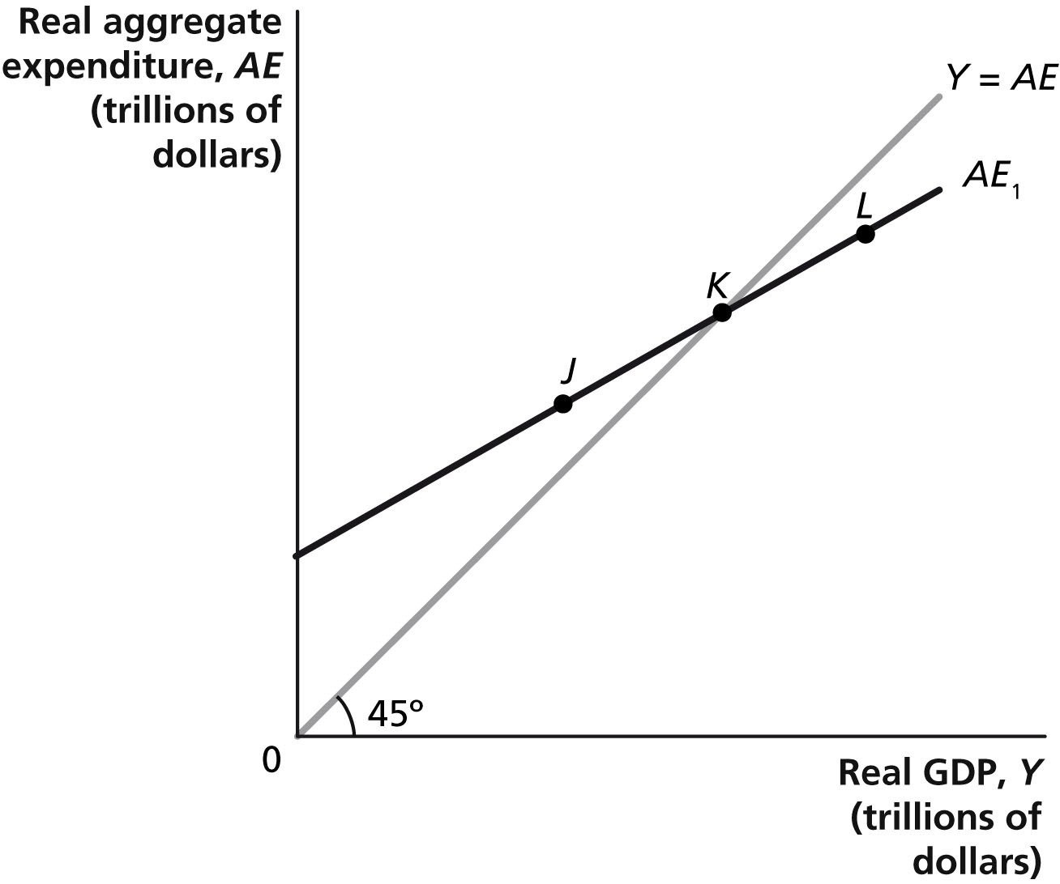15. Refer to the expenditure model opposite. If the economy is at point *L*, what will happen?

A. Inventories have fallen below their desired level, and firms decrease production.

B. Inventories have fallen below their desired level, and firms increase production.

C. Inventories have risen above their desired level, and firms decrease production.

D. Inventories have risen above their desired level, and firms increase production.

16. Suppose that government spending increases, shifting up the aggregate expenditure line and GDP increases by $400 billion. If the MPC is 0.75, then by how much did government spending change?

A. $10 billion

B. $100 billion

C. $200 billion

D. $300 billion

17. Which of the following changes would NOT shift the aggregate demand curve?

A. a change in fiscal policy

B. a change in monetary policy

C. a change in expectations about future income

D. a change in technology

18. In the short run, a decrease in the cash rate

A. lowers the real interest rate, decreases investment, and shifts the *AD* curve rightward.

B. lowers the real interest rate, increases investment, and shifts the *AD* curve leftward.

C. raises the real interest rate, decreases investment, and shifts the *AD* curve rightward.

D. None of the above answers is correct.

19. An increase in the government ________ reduces the government's ________.

A. budget deficit; debt

B. budget surplus; debt

C. debt; budget deficit

D. None of the above answers is correct.

20. An increase in the price of a resource such as oil

I. shifts the aggregate demand curve leftward.

II. shifts the aggregate supply curve leftward.

III. increases the price level and decreases real GDP in the short run.

A. Only I is correct.

B. Only II is correct.

C. Both II and III are correct.

D. I, II, and III are correct.

21. Which component of aggregate expenditure is typically the smallest?

A. Consumption

B. Investment

C. Government

D. Net exports

22. Suppose the economy is at potential GDP and business and consumer confidence increases. Which of the following is most likely to occur?

A. Inflation will increase.

B. Actual GDP will decline.

C. The aggregate supply curve will shift to the right.

D. Unemployment will increase.

23. The main purpose of microeconomic reform is to increase economic growth by

A. increasing aggregate demand through higher investment.

B. reducing inflationary pressures and increasing employment.

C. reducing the current account deficit and foreign debt.

D. increasing aggregate supply through improved efficiency.

24. If the marginal propensity to consume is 0.6 and the government increases spending by $100 million and at the same time increases income taxes by $100 million, then GDP will

A. not change.

B. increase by $60 million.

C. increase by $100 million.

D. increase by $250 million.

__________________________________________________________________

***End of Section 1***

**Section Two: Data interpretation/Short response 36% (36 Marks)**

This section contains **three (3)** questions. Answer **all** questions. Write your answers in the spaces provided.

Spare pages are included at the end of this booklet. They can be used as additional space if required to continue an answer. If you need to use the space to continue an answer, indicate in the original answer space where the answer is continued, i.e. give the page number. Fill in the number of the question(s) that you are continuing to answer at the top of the page.

Suggested working time: 65 minutes.

_________________________________________________________________________

**Question 25 (12 marks)**

Commonwealth Government Budget Balance

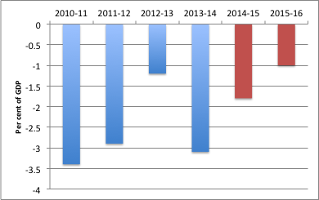

a. i. In which year(s) did the budget deficit exceed 3 per cent of GDP? (1 mark)

__________________________________________________________________

ii. In which year(s) did the government budget balance decrease compared to the previous year? (1 mark)

__________________________________________________________________

b. Explain the effect of a business cycle contraction on the government’s budget balance. (4 marks)

________________________________________________________________________________________________________________________________________________________________________________________________________________________________________________________________________________________________________________________________________________________________________________________________________________________________________________________________________________________________________________________________________________________________________________________________

________________________________________________________________________________________________________________________________________________________________________________________________________________________________________________________________________________________________________________________________________________________________________________________________________________________________________________________________________________________________________________________________________________________________________________________________________________________________________________________________________________________________________________________________________________

c. The present government has planned for a significant decrease in the budget deficit for 2014-15. Explain the effect this would have on the economy. Use the AD/AS model to help explain your answer. Why would the government want to reduce the size of the budget deficit? (6 marks)

________________________________________________________________________________________________________________________________________________________________________________________________________________________________________________________________________________________________________________________________________________________________________________________________________________________________________________________________________________________________________________________

________________________________________________________________________________________________________________________________________________________________________________________________________________________________________________________________________________________________________________________________________________________________________________________________________________________________________________________________________________________________________________________________________________________________________________________________________________________________________________________________________________________________________________________________________________________________________________________________________________________________________________________________________________________________

________________________________________________________________________________________________________________________________________________________________________________________________________________________________________________________________________________________________________________________________________________________________________

**Question 26 (12 marks)**

Refer to the data below showing expenditure on GDP for the Australian economy.

*Expenditure on GDP $ million (seasonally adjusted)*

*Dec 12 Dec 13 % change*

*Consumption 203 078 208 386 2.6*

*Investment 87 093 86 708 -0.4*

*Government 87 424 86 990 -0.5*

*Exports 82 785 88 156 6.5*

*Imports 81 133 77 403 -4.6*

*GDP**379 977 390 572 _____*

a. i. Between Dec 2012 and Dec 2013, GDP grew by ______% (1 mark)

ii. In Dec 2013, net exports equaled ______ % of GDP (1 mark)

b. Describe two factors that could have caused the decline in investment expenditure and two factors that could have caused the increase in exports. (4 marks)

________________________________________________________________________________________________________________________________________________________________________________________________________________________________________________________________________________________________________________________________________________________________________________________________________________________________________________________________________________________________________________________________________________________________________________________________

________________________________________________________________________________________________________________________________________________________________________________________________________________________________________________________________________________________________________________________________________________________________________________________________________________________________________________________________________________________________________________________________________________________________________________________________________________________________________________________________________________________________________________________________________________

c. Referring to the data, describe the state of the economy in Dec 2013. What would be the implications for the labour market and for monetary policy? (6 marks)

________________________________________________________________________________________________________________________________________________________________________________________________________________________________________________________________________________________________________________________________________________________________________________________________________________________________________________________________________________________________________________________

________________________________________________________________________________________________________________________________________________________________________________________________________________________________________________________________________________________________________________________________________________________________________________________________________________________________________________________________________________________________________________________________________________________________________________________________________________________________________________________________________________________________________________________________________________________________________________________________________________________________________________________________________________________________

________________________________________________________________________________________________________________________________________________________________________________________________________________________________________________________________________________________________________________________________________________________________________

**Question 27 (12 marks)**

**Refer to the information below**

*Australia signed an FTA (free trade agreement) with South Korea in April 2014 and an EPA (economic partnership agreement) with Japan in July 2014 – two of Australia’s four largest trading partners. These agreements are good for the economy, good for growth, good for farmers, good for job creation and good for consumers. For agriculture, Korea will eliminate tariffs immediately on entry into force for raw sugar, wheat, wine, and some horticulture, while 88 per cent of Australia’s manufactures, resources and energy exports will enter Korea duty free. The Japan-Australia EPA will deliver significant benefits to Australian farmers, manufacturers, exporters, service providers and consumers. For example, 99.7 per cent of Australia’s exports of resource, energy and manufacturing products will enter Japan duty-free. Australian tariffs on Japanese imports will also be eliminated – this includes removing tariffs on Japanese motor vehicles, electronics and white goods.* *(Source: DFAT)*

a. Who are Australia’s four largest trading partners? (2 marks)

______________________________________________________________________

b. What is the purpose of a free trade agreement? Why are FTAs seen as being good for growth and good for job creation? (4 marks)

________________________________________________________________________________________________________________________________________________________________________________________________________________________________________________________________________________________________________________________________________________________________________________________________________________________________________________________________________________________________________________________________________________________________________________________________

________________________________________________________________________________________________________________________________________________________________________________________________________________________________________________________________________________________________________________________________________________________________________________________________________________________________________________________________________________________________________________________________________________________________________________________________________________________________________________________________________

c. As part of the JAEPA, Australian tariffs on Japanese imports will be eliminated.Use a model to show how this will affect different groups in the economy and whether the net effect will be positive or negative. (6 marks)

________________________________________________________________________________________________________________________________________________________________________________________________________________________________________________________________________________________________________________________________________________________________________________________________________________________________________________________________________________________________________________________

________________________________________________________________________________________________________________________________________________________________________________________________________________________________________________________________________________________________________________________________________________________________________________________________________________________________________________________________________________________________________________________________________________________________________________________________________________________________________________________________________________________________________________________________________________________________________________________________________________________________________________________________________________________________

________________________________________________________________________________________________________________________________________________________________________________________________________________________________________________________________________________________________________________________________________________________________________

***End of Section 2***

**Section Three: Extended response 40% (40 Marks)**

This section contains **four (4)** questions. Answer **two (2)** questions.

Write your answers on the lined pages provided.

Pages are included at the end of this booklet for planning and writing your answer.

* Planning: If you use the spare pages for planning, indicate this clearly at the top of the page.
* Answering the question: In the pages provided indicate clearly the number of the question you are answering.

Suggested working time: 80 minutes.

**___________________________________________________________________________________________________________________________________**

**Question 28** **(20 marks)**

a. Demonstrate and explain how a freely floating exchange rate is determined. Identify three key factors that are important influences on the Australian dollar. (10 marks)

b. Show how movements in the exchange rate can have significant effects on the balance of payments, the rate of inflation and the level of economic activity. (10 marks)

___________________________________________________________________________________________________________________________________

**Question 29** **(20 marks)**

a. Outline the main economic policy objectives and discuss the extent to which these objectives may conflict and complement each other. (10 marks)

b. Describe the time lags which occur in the use of fiscal and monetary policy and explain how these lags can limit the effectiveness of both fiscal and monetary policy. (10 marks)

**____________________________________________________________________________________________________________________________________**

**Question 30** **(20 marks)**

a. Explain the relationship between the business cycle and the economic indicators of inflation, unemployment and economic growth. (10 marks)

b. Use the AD/AS model to explain the causes of a business cycle expansion. Distinguish between the factors that can lead to an increase in AD and an increase in AS. (10 marks)

____________________________________________________________________________________________________________________________________

**Question 31** **(20 marks)**

a. The current account deficit has fallen from 4.5% of GDP in the December quarter 2012 to just 1.4% in the March quarter 2014. What factors could have caused this significant change? (10 marks)

b. Define the concept of foreign liabilities and explain the relationship between foreign liabilities and the current account outcome. (10 marks)

____________________________________________________________________________________________________________________________________

***End of Exam***

|  |
| --- |
|  |
|  |
|  |
|  |
|  |
|  |
|  |
|  |
|  |
|  |
|  |
|  |
|  |
|  |
|  |
|  |
|  |
|  |
|  |
|  |
|  |
|  |
|  |
|  |
|  |
|  |
|  |
|  |
|  |
|  |
|  |
|  |
|  |
|  |
|  |

|  |
| --- |
|  |
|  |
|  |
|  |
|  |
|  |
|  |
|  |
|  |
|  |
|  |
|  |
|  |
|  |
|  |
|  |
|  |
|  |
|  |
|  |
|  |
|  |
|  |
|  |
|  |
|  |
|  |
|  |
|  |
|  |
|  |
|  |
|  |
|  |
|  |
|  |
|  |

|  |
| --- |
|  |
|  |
|  |
|  |
|  |
|  |
|  |
|  |
|  |
|  |
|  |
|  |
|  |
|  |
|  |
|  |
|  |
|  |
|  |
|  |
|  |
|  |
|  |
|  |
|  |
|  |
|  |
|  |
|  |
|  |
|  |
|  |
|  |
|  |
|  |
|  |
|  |

|  |
| --- |
|  |
|  |
|  |
|  |
|  |
|  |
|  |
|  |
|  |
|  |
|  |
|  |
|  |
|  |
|  |
|  |
|  |
|  |
|  |
|  |
|  |
|  |
|  |
|  |
|  |
|  |

|  |
| --- |
|  |
|  |
|  |
|  |
|  |
|  |
|  |
|  |
|  |
|  |
|  |
|  |
|  |
|  |
|  |
|  |
|  |
|  |
|  |
|  |
|  |
|  |
|  |
|  |
|  |
|  |
|  |
|  |
|  |
|  |
|  |
|  |
|  |
|  |
|  |
|  |
|  |
|  |
|  |
|  |
|  |
|  |
|  |
|  |
|  |
|  |
|  |
|  |
|  |
|  |
|  |
|  |
|  |
|  |
|  |
|  |
|  |
|  |
|  |
|  |
|  |
|  |
|  |
|  |
|  |
|  |
|  |
|  |
|  |
|  |
|  |
|  |
|  |

|  |
| --- |
|  |
|  |
|  |
|  |
|  |
|  |
|  |
|  |
|  |
|  |
|  |
|  |
|  |
|  |
|  |
|  |
|  |
|  |
|  |
|  |
|  |
|  |
|  |
|  |
|  |
|  |
|  |
|  |
|  |
|  |
|  |
|  |
|  |
|  |
|  |
|  |
|  |
|  |
|  |
|  |
|  |
|  |
|  |
|  |
|  |
|  |
|  |
|  |
|  |
|  |
|  |
|  |
|  |
|  |
|  |
|  |
|  |
|  |
|  |
|  |
|  |

|  |
| --- |
|  |
|  |
|  |
|  |
|  |
|  |
|  |
|  |
|  |
|  |
|  |
|  |
|  |
|  |
|  |
|  |
|  |
|  |
|  |
|  |
|  |
|  |
|  |
|  |
|  |
|  |
|  |
|  |
|  |
|  |
|  |
|  |
|  |
|  |
|  |
|  |
|  |

|  |
| --- |
|  |
|  |
|  |
|  |
|  |
|  |
|  |
|  |
|  |
|  |
|  |
|  |
|  |
|  |
|  |
|  |
|  |
|  |
|  |
|  |
|  |
|  |
|  |
|  |
|  |
|  |
|  |
|  |
|  |
|  |
|  |
|  |
|  |
|  |
|  |
|  |
|  |

|  |
| --- |
|  |
|  |
|  |
|  |
|  |
|  |
|  |
|  |
|  |
|  |
|  |
|  |
|  |
|  |
|  |
|  |
|  |
|  |
|  |
|  |
|  |
|  |
|  |
|  |
|  |
|  |
|  |
|  |
|  |
|  |
|  |
|  |